Parallelogram-Base Pyramid
# Source: AI Source: Provided by: [Data Path: Persons Table -> ID Column: 1, Name_En Column: Motasem Essam] -> From: [ChatGPT] on [7/25/2026]
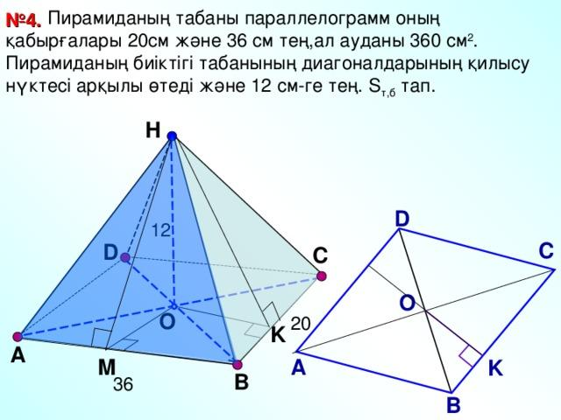

Definition
# Source: AI Source: Provided by: [Data Path: Persons Table -> ID Column: 1, Name_En Column: Motasem Essam] -> From: [ChatGPT] on [7/25/2026]
A parallelogram-base pyramid is a three-dimensional geometric solid whose base is a parallelogram and whose lateral faces are four triangles that meet at a single point called the apex.
A parallelogram has two pairs of opposite sides that are parallel and equal in length. Its opposite angles are equal, but its angles do not have to be right angles.
A parallelogram-base pyramid has:
- 1 parallelogram base.
- 4 triangular lateral faces.
- 5 faces in total.
- 8 edges in total.
- 5 vertices in total.
The apex may lie directly above a designated center of the base, giving a right pyramid under the chosen convention, or away from that position, giving an oblique pyramid.

Simple Definition
# Source: AI Source: Provided by: [Data Path: Persons Table -> ID Column: 1, Name_En Column: Motasem Essam] -> From: [ChatGPT] on [7/25/2026]
A parallelogram-base pyramid is a pyramid with a parallelogram at the bottom and four triangular sides that meet at one top point.

Key Characteristics
# Source: AI Source: Provided by: [Data Path: Persons Table -> ID Column: 1, Name_En Column: Motasem Essam] -> From: [ChatGPT] on [7/25/2026]
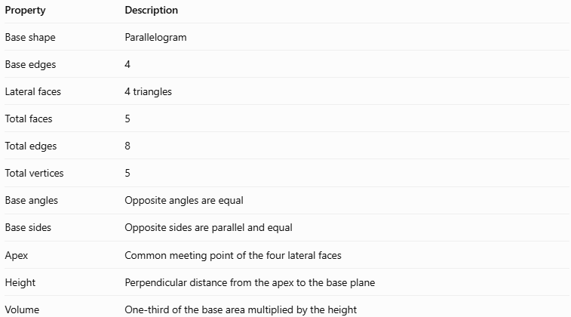
Property | Description
Base shape | Parallelogram
Base edges | 4
Lateral faces | 4 triangles
Total faces | 5
Total edges | 8
Total vertices | 5
Base angles | Opposite angles are equal
Base sides | Opposite sides are parallel and equal
Apex | Common meeting point of the four lateral faces
Height | Perpendicular distance from the apex to the base plane
Volume | One-third of the base area multiplied by the height

Geometric Representation
# Source: AI Source: Provided by: [Data Path: Persons Table -> ID Column: 1, Name_En Column: Motasem Essam] -> From: [ChatGPT] on [7/25/2026]
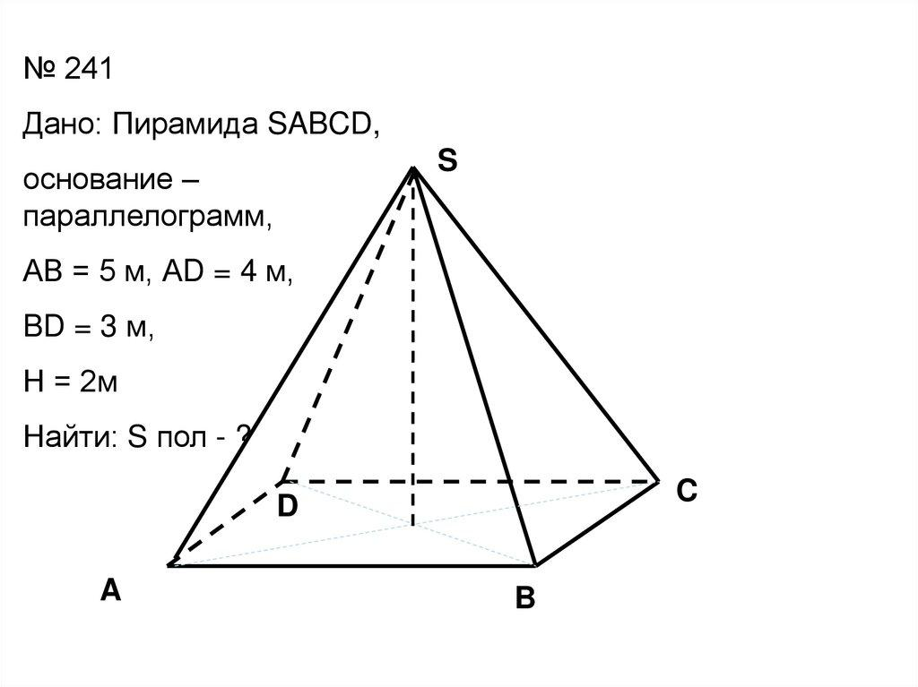
The main components are:
- Base: The parallelogram at the bottom, with two pairs of opposite sides parallel.
- Lateral faces: Four triangular surfaces connecting the base edges to the apex.
- Base edges: The four sides of the parallelogram.
- Lateral edges: Four line segments connecting the apex to the four base vertices.
- Apex: The vertex where the four triangular faces meet.
- Height: The perpendicular distance from the apex to the plane containing the base. It is not necessarily the length of a lateral edge.
The triangular faces need not all be congruent. Their sizes and shapes depend on the base dimensions and the position of the apex.

Mathematical Representations and Formulas
# Source: AI Source: Provided by: [Data Path: Persons Table -> ID Column: 1, Name_En Column: Motasem Essam] -> From: [ChatGPT] on [7/25/2026]
Let:
- $a$ and $b$ be the lengths of adjacent sides of the parallelogram.
- $θ$ be the angle between those sides.
- $h$ be the perpendicular height of the pyramid.
- $B$ be the area of the base.
- $P$ be the perimeter of the base.

Base Area
# Source: AI Source: Provided by: [Data Path: Persons Table -> ID Column: 1, Name_En Column: Motasem Essam] -> From: [ChatGPT] on [7/25/2026]
The area of a parallelogram is the product of one side and the perpendicular distance between that side and its opposite side.
$$B=ab\sin{θ}$$
Alternatively, using a base side and its corresponding perpendicular altitude:
$$B=ab_{h}$$
Here, $b_{h}$ represents the perpendicular altitude corresponding to side $a$, not necessarily the adjacent side length $b$.

Base Perimeter
# Source: AI Source: Provided by: [Data Path: Persons Table -> ID Column: 1, Name_En Column: Motasem Essam] -> From: [ChatGPT] on [7/25/2026]
$$P=2\left(a+b\right)$$

Volume
# Source: AI Source: Provided by: [Data Path: Persons Table -> ID Column: 1, Name_En Column: Motasem Essam] -> From: [ChatGPT] on [7/25/2026]
The volume of any pyramid is one-third of the product of its base area and perpendicular height.
$$V=\frac{1}{3}Bh$$
For a parallelogram-base pyramid:
$$\boxed{V=\frac{1}{3}abh\sin{θ}}$$

Lateral Surface Area
# Source: AI Source: Provided by: [Data Path: Persons Table -> ID Column: 1, Name_En Column: Motasem Essam] -> From: [ChatGPT] on [7/25/2026]
The lateral surface area is the sum of the areas of the four triangular lateral faces:
$$A_{L}=A_{1}+A_{2}+A_{3}+A_{4}$$
For an individual triangular face:
$$A_{i}=\frac{1}{2}s_{i}l_{i}$$
where $s_{i}$ is the corresponding base-edge length and $l_{i}$ is the perpendicular height of that triangular face, measured within its plane.
For an oblique pyramid, the four face areas should generally be calculated separately.
For a right parallelogram-base pyramid whose apex lies directly above the intersection of the base diagonals, define:
$$l_{a}=\sqrt{h^{2}+{\left(\frac{b\sin{θ}}{2}\right)}^{2}}$$
$$l_{b}=\sqrt{h^{2}+{\left(\frac{a\sin{θ}}{2}\right)}^{2}}$$
Then the lateral surface area is:
$$\boxed{A_{L}=al_{a}+bl_{b}}$$
This formula applies to that specific right-pyramid configuration; it is not a general formula for every parallelogram-base pyramid.

Total Surface Area
# Source: AI Source: Provided by: [Data Path: Persons Table -> ID Column: 1, Name_En Column: Motasem Essam] -> From: [ChatGPT] on [7/25/2026]
$$\boxed{A_{T}=B+A_{L}}$$
The total surface area includes the parallelogram base and all four triangular faces.

6.6 Euler’s Formula
# Source: AI Source: Provided by: [Data Path: Persons Table -> ID Column: 1, Name_En Column: Motasem Essam] -> From: [ChatGPT] on [7/25/2026]
For a convex parallelogram-base pyramid:
$$V_{e}-E+F=2$$
Substituting its vertex, edge, and face counts:
$$5-8+5=2$$
Therefore, it satisfies Euler’s formula for convex polyhedra.

Worked Examples
# Source: AI Source: Provided by: [Data Path: Persons Table -> ID Column: 1, Name_En Column: Motasem Essam] -> From: [ChatGPT] on [7/25/2026]
Example 1: Finding the Base Area
A parallelogram base has adjacent sides of $8\text{ cm}$ and $5\text{ cm}$, with an included angle of ${30}^{∘}$. Find the base area.
Using:
$$B=ab\sin{θ}$$
Substitute the values:
$$B=8\left(5\right){\sin{30}}^{∘}$$
Since ${\sin{30}}^{∘}=\frac{12}{}$:
$$B=40\left(\frac{1}{2})\right.$$
$$\boxed{B=20{\text{ cm}}^{2}}$$
Example 2: Finding the Volume
A parallelogram-base pyramid has a base area of $36{\text{ cm}}^{2}$ and a perpendicular height of $9\text{ cm}$. Find its volume.
Using:
$$V=\frac{1}{3}Bh$$
$$V=\frac{1}{3}\left(36\right)\left(9\right)$$
$$\boxed{V=108{\text{ cm}}^{3}}$$
Example 3: Finding the Base Perimeter
A parallelogram base has adjacent sides of $7\text{ cm}$ and $4\text{ cm}$. Find its perimeter.
$$P=2\left(a+b\right)$$
$$P=2\left(7+4\right)=22$$
$$\boxed{P=22\text{ cm}}$$
Example 4: Finding the Number of Faces, Edges, and Vertices
For a pyramid with a four-sided base, $n=4$.
The formulas are:
$$F=n+1, E=2n, V_{e}=n+1$$
Therefore:
$$F=5, E=8, V_{e}=5$$
Answer: 5 faces, 8 edges, and 5 vertices.

Comparison with Related Pyramids
# Source: AI Source: Provided by: [Data Path: Persons Table -> ID Column: 1, Name_En Column: Motasem Essam] -> From: [ChatGPT] on [7/25/2026]
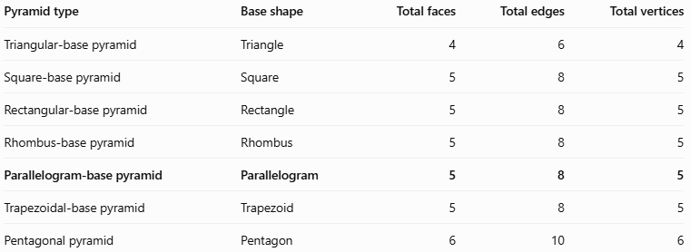
Pyramid type | Base shape | Total faces | Total edges | Total vertices
Triangular-base pyramid | Triangle | 4 | 6 | 4
Square-base pyramid | Square | 5 | 8 | 5
Rectangular-base pyramid | Rectangle | 5 | 8 | 5
Rhombus-base pyramid | Rhombus | 5 | 8 | 5
Parallelogram-base pyramid | Parallelogram | 5 | 8 | 5
Trapezoidal-base pyramid | Trapezoid | 5 | 8 | 5
Pentagonal pyramid | Pentagon | 6 | 10 | 6
A square, rectangle, and rhombus are special types of parallelograms. Consequently, under inclusive classification, their corresponding pyramids are also parallelogram-base pyramids.
However, the names are useful because they identify the more specific shape of the base.

Constructing Parallelogram-Base Pyramid in Solid Geometry

Instruments Used
# Source: AI Source: Provided by: [Data Path: Persons Table -> ID Column: 1, Name_En Column: Motasem Essam] -> From: [ChatGPT] on [7/25/2026]
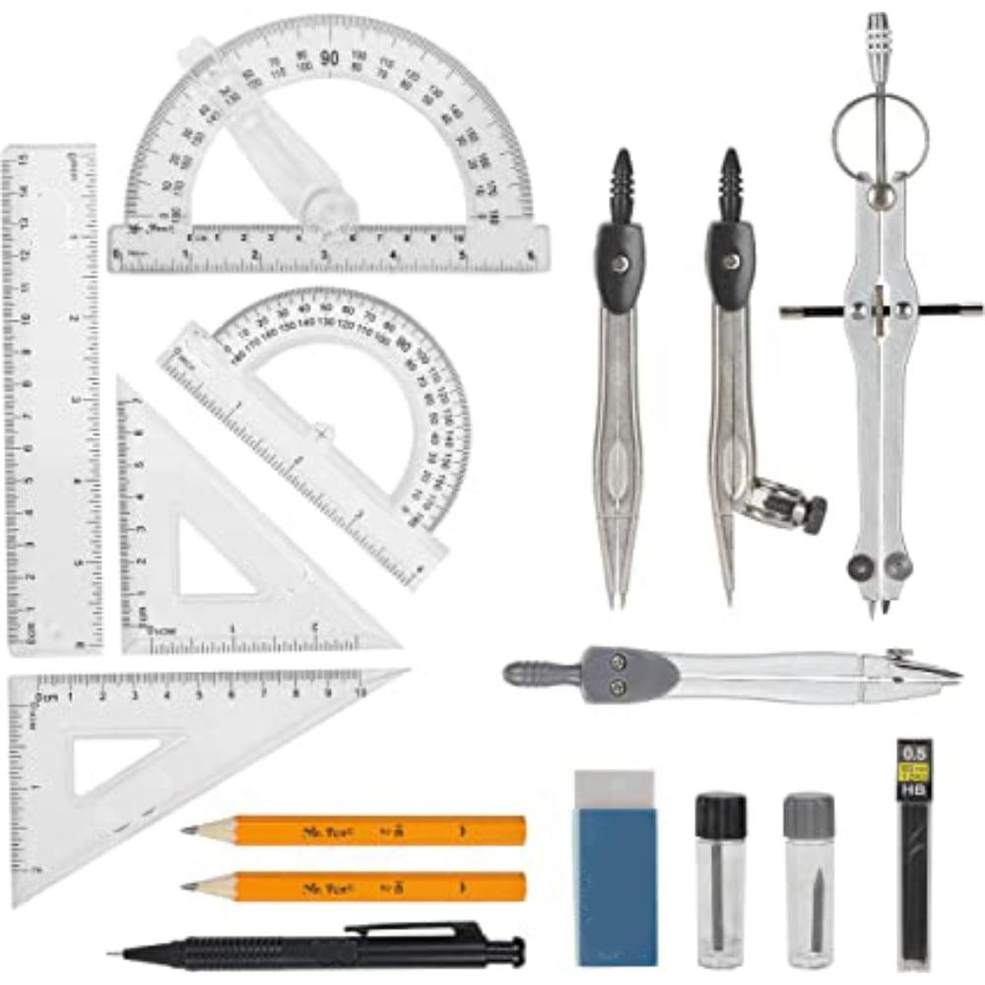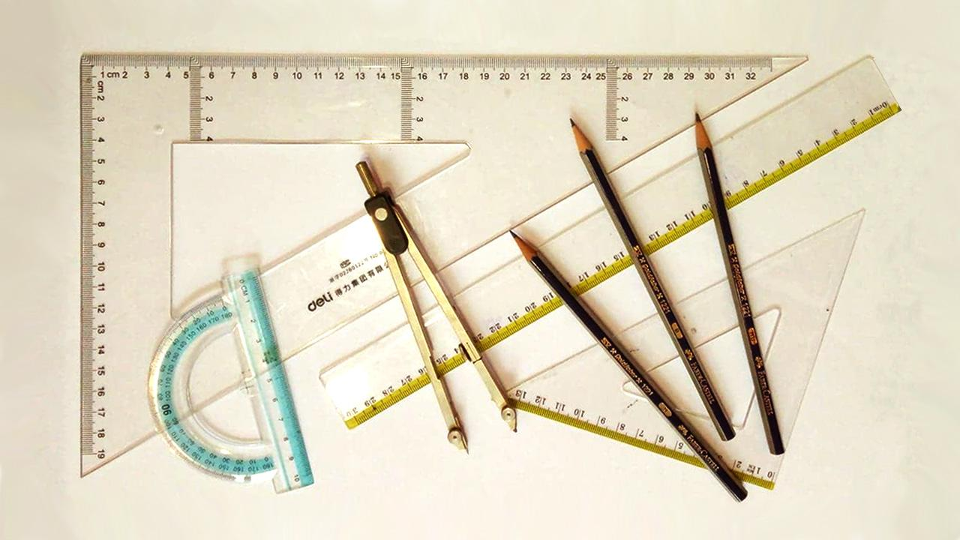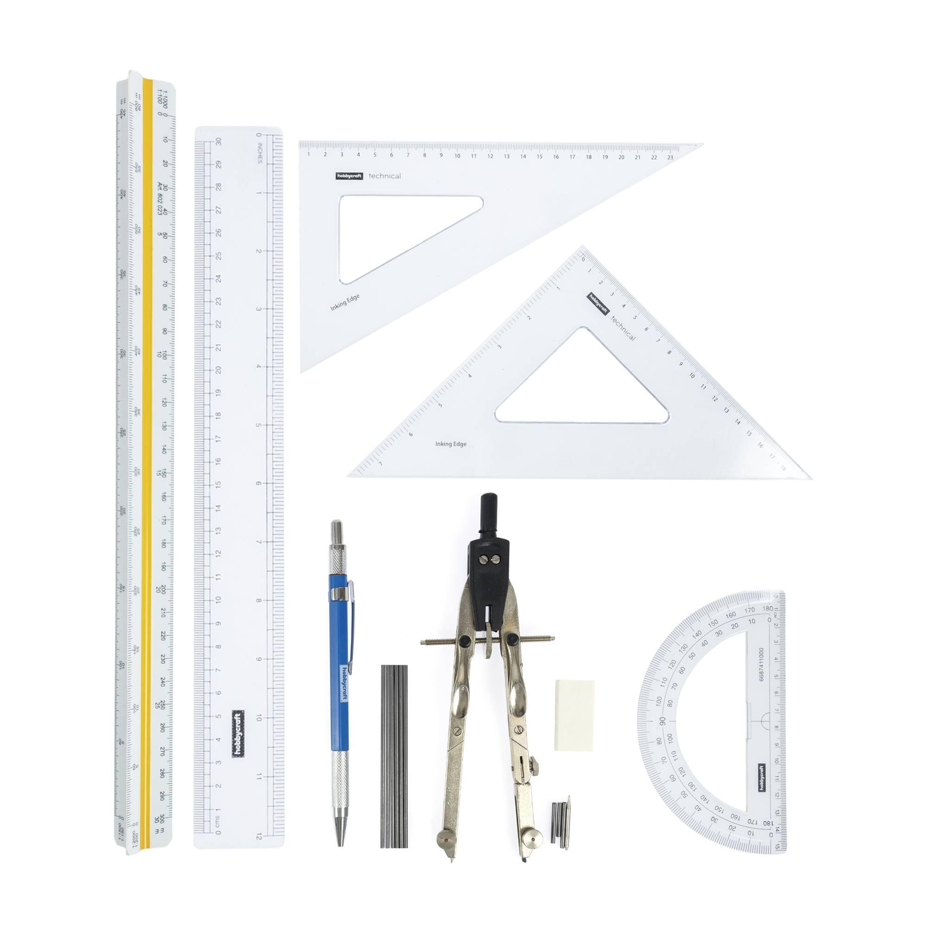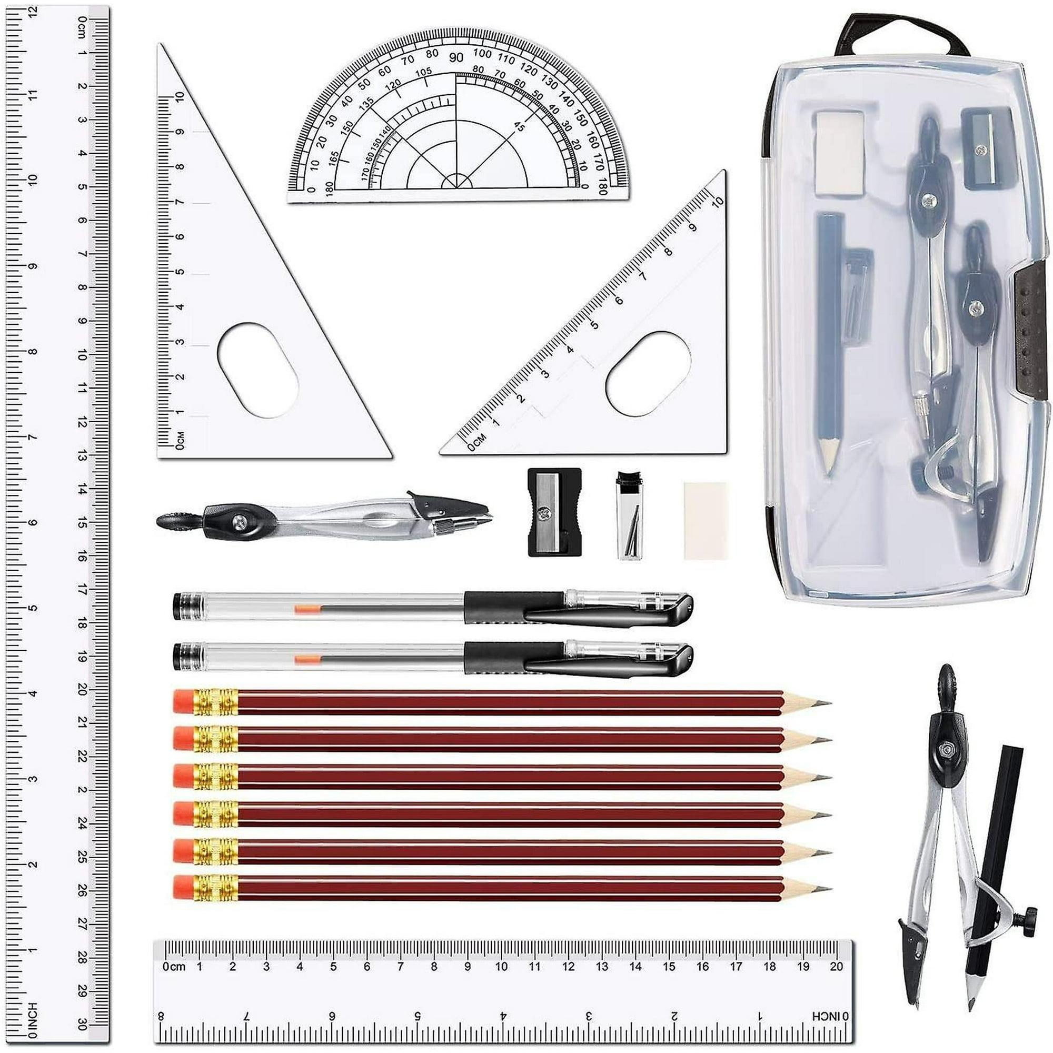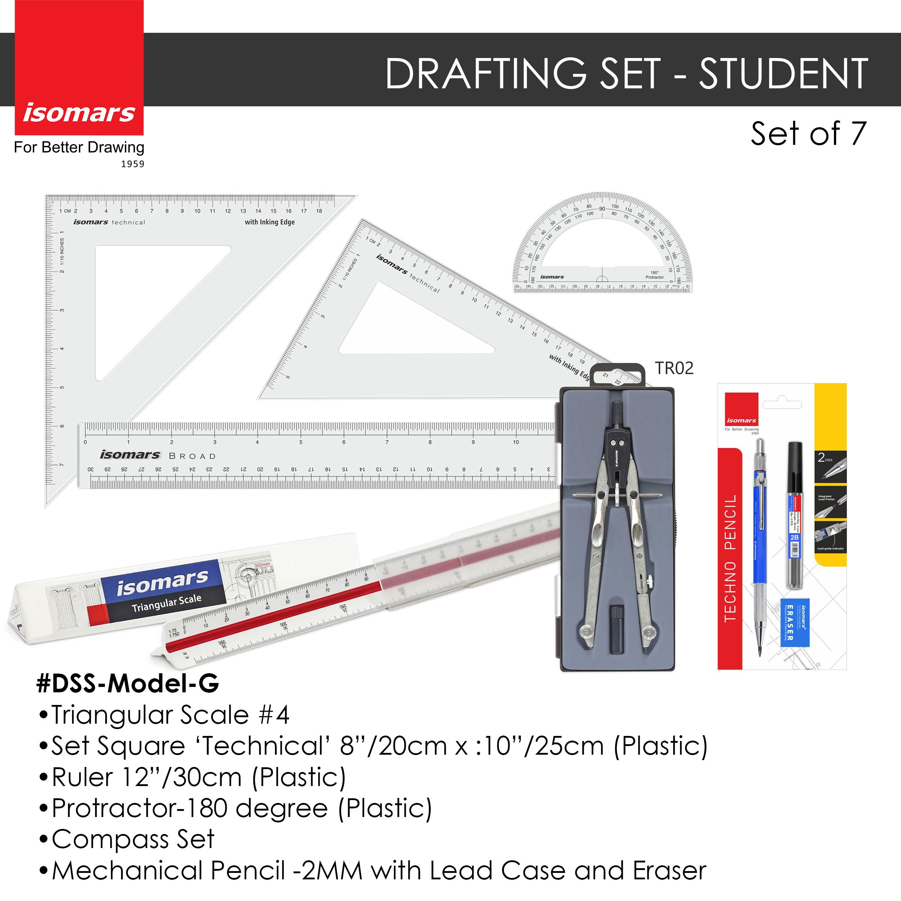
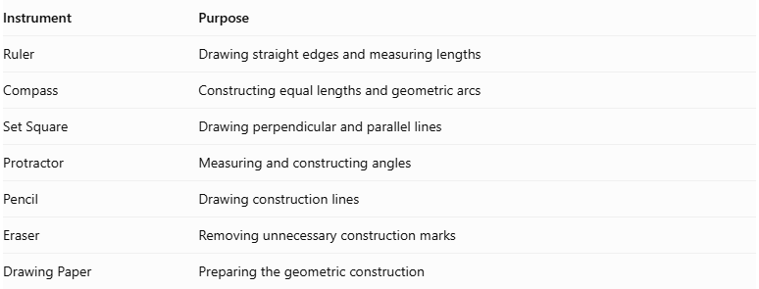
Instrument | Purpose
Ruler | Drawing straight edges and measuring lengths
Compass | Constructing equal lengths and geometric arcs
Set Square | Drawing perpendicular and parallel lines
Protractor | Measuring and constructing angles
Pencil | Drawing construction lines
Eraser | Removing unnecessary construction marks
Drawing Paper | Preparing the geometric construction
Construction Method: Instrument-Based

Construction Procedures

Constructing the Parallelogram Base
# Source: AI Source: Provided by: [Data Path: Persons Table -> ID Column: 1, Name_En Column: Motasem Essam] -> From: [ChatGPT] on [7/25/2026]
- Draw one side of the parallelogram using a ruler.
- Use a protractor to construct the required interior angle at one endpoint.
- Mark the length of the adjacent side along the constructed direction.
- Through the opposite endpoints, construct parallel lines using a ruler and set square.
- Complete the parallelogram by connecting the remaining endpoints.
- Verify that opposite sides are parallel and equal.

Constructing a Right Parallelogram-Base Pyramid
# Source: AI Source: Provided by: [Data Path: Persons Table -> ID Column: 1, Name_En Column: Motasem Essam] -> From: [ChatGPT] on [7/25/2026]
- Construct the parallelogram base.
- Draw its two diagonals to locate their intersection, which is the center of the base.
- Draw a perpendicular line through the center of the base.
- Mark the desired perpendicular height on this line.
- Label the endpoint as the apex.
- Connect the apex to all four base vertices.
- Draw visible edges using solid lines.
- Draw hidden edges using dashed lines where appropriate.
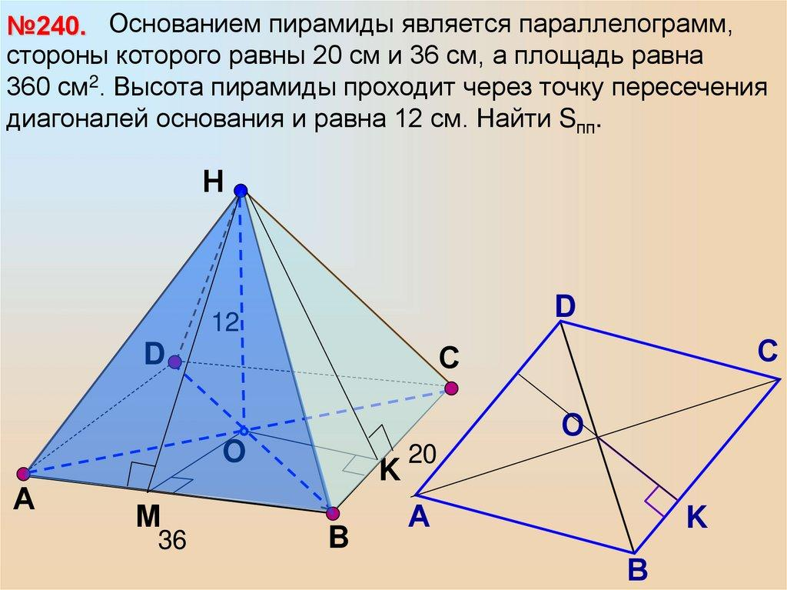

Constructing an Oblique Parallelogram-Base Pyramid
# Source: AI Source: Provided by: [Data Path: Persons Table -> ID Column: 1, Name_En Column: Motasem Essam] -> From: [ChatGPT] on [7/25/2026]
- Construct the parallelogram base.
- Select an apex position that is not directly above the center of the parallelogram.
- Draw the apex above the base plane.
- Connect the apex to all four base vertices.
- Distinguish visible and hidden edges.
- Verify that all four lateral faces are triangular.
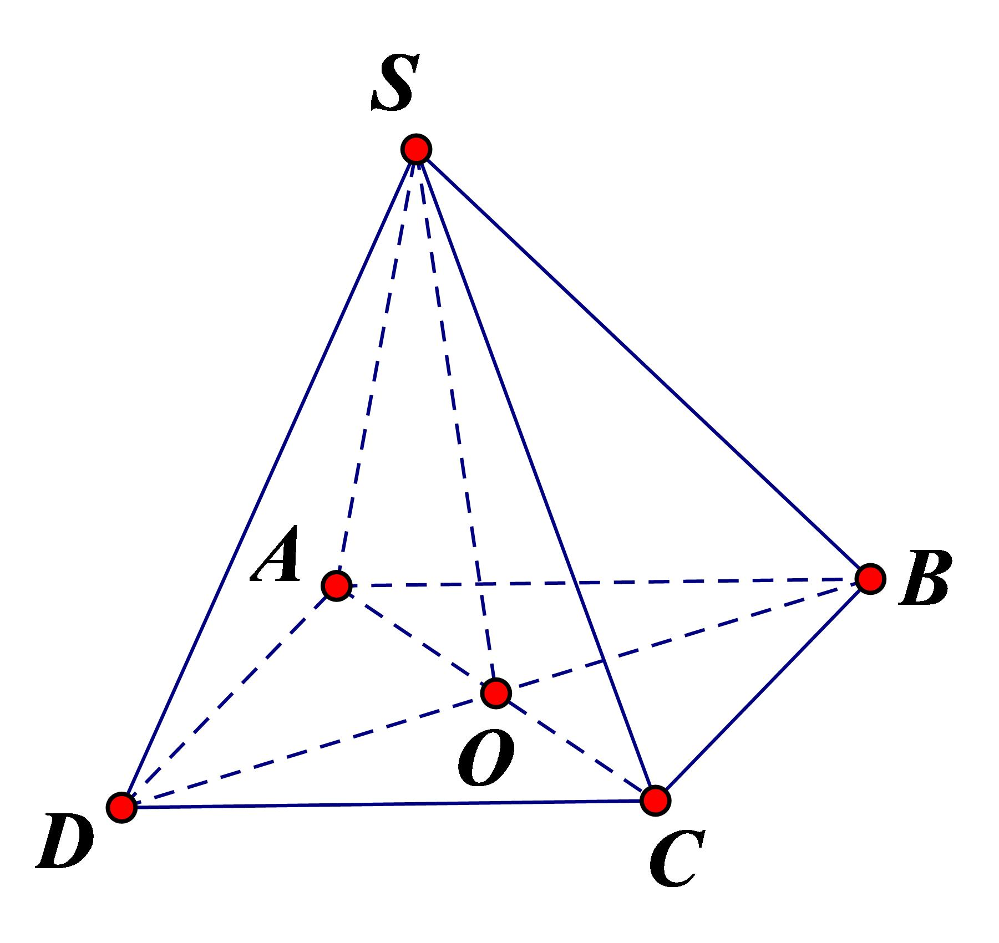

Constructing the Net of a Parallelogram-Base Pyramid
# Source: AI Source: Provided by: [Data Path: Persons Table -> ID Column: 1, Name_En Column: Motasem Essam] -> From: [ChatGPT] on [7/25/2026]
- Draw a parallelogram representing the base.
- Construct four triangular faces, one attached to each side of the parallelogram.
- Determine the dimensions of each triangle using the corresponding lateral edges.
- Add joining flaps if the net is intended for physical assembly.
- Cut and fold the net to form the pyramid.
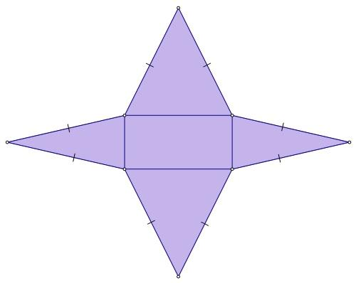

Applications
# Source: AI Source: Provided by: [Data Path: Persons Table -> ID Column: 1, Name_En Column: Motasem Essam] -> From: [ChatGPT] on [7/25/2026]
Parallelogram-base pyramids can be useful in:
- Geometry education: Studying quadrilateral bases, triangular faces, edges, vertices, and three-dimensional solids.
- Architectural design: Developing conceptual forms with sloping triangular sides and a parallelogram footprint.
- 3D modeling: Constructing polyhedral shapes in CAD and computer graphics.
- Engineering and fabrication: Calculating material areas and enclosed volume for suitably shaped components.
- Mathematical visualization: Exploring how changing the base angles or moving the apex affects the shape and symmetry of a solid.

Key Points
# Source: AI Source: Provided by: [Data Path: Persons Table -> ID Column: 1, Name_En Column: Motasem Essam] -> From: [ChatGPT] on [7/25/2026]
- A parallelogram-base pyramid is a quadrilateral pyramid.
- Its base is a parallelogram with two pairs of opposite sides parallel.
- It has 5 faces, 8 edges, and 5 vertices.
- Its four lateral faces are triangles.
- Its base area is $B=ab\sin{θ}$.
- Its volume is $V=\frac{1}{3}Bh$.
- Its lateral surface area is the sum of its four triangular face areas.
- The perpendicular height is measured from the apex to the base plane.
- Square-base, rectangular-base, and rhombus-base pyramids are special cases of parallelogram-base pyramids.

Conclusion
# Source: AI Source: Provided by: [Data Path: Persons Table -> ID Column: 1, Name_En Column: Motasem Essam] -> From: [ChatGPT] on [7/25/2026]
A parallelogram-base pyramid is a three-dimensional polyhedron formed by a parallelogram base and four triangular lateral faces that meet at an apex. It shares the same basic face, edge, and vertex counts as other quadrilateral pyramids, while its parallelogram base gives it a distinct geometric structure.
Understanding this solid helps connect the properties of quadrilaterals with the structure and measurements of pyramids. Its base area and volume can be calculated using standard formulas, while its surface area depends on the dimensions and orientation of the individual triangular faces.

